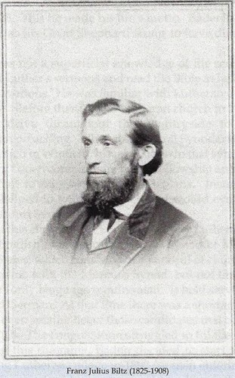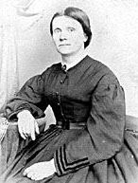

Obtained from Warren Schmidt (wrschmidt25@gmail.com) by e-mail on 7 June 2015.

FRANZ JULIUS BILTZ (1825-1908) and his wife, MARIA von WURMB (1830-1891)

Franz Julius Biltz came to the United States with his half-sister, Louise Voelker. His father had died when he was two years old, and his mother died two years before the immigration took place. Julius did not have the blessing of his guardian to leave Germany and even had to hide from authorities who were sent to retrieve him from the ship. Louise was twenty-two years old and Julius was thirteen years old when they made this life-changing journey. Such a voyage with two young people traveling with no parental presence must have been both exciting and frightening at the same time.
Louis Voelker was listed as one of Rev. Martin Stephan’s maids when the trip was made from Germany to America. Once here, she married Christian Adolf Bergt who lived in the new settlement of Frohna in Perry County. The log cabin which was owned by the Bergts is now the centerpiece of the historical interpretation at the Saxon Lutheran Memorial in Frohna. The Bergt family went on to be known as a family that spread throughout the Midwest, producing many men and women who went on to serve their church as pastors and teachers.
Franz Julius Biltz lived with the Loeber family after he arrived in Perry County. This was probably because the Loeber family recognized the fact that this orphan boy needed to have a place to stay which was relatively close to the Log Cabin College so he could attend that school. Julius was from Niederfrohna in Germany. Other immigrants from there settled in Frohna when they got to Perry County. The trip from Frohna to Dresden, where the College was located, would have been a lengthy one for a young boy. Staying with the Loebers would have resolved this problem. It was still going to be a trip of about a mile from the Loeber parsonage to the school, but the trip would be much shorter and Julius would have the advantage of making that walk or carriage ride along with the two Loeber children who were his classmates. It must have been a great blessing for Julius to experience being part of the Loeber family. There he would certainly have learned valuable lessons about leading a family and leading a congregation.
Julius completed his studies at the Log Cabin College to become one of the five graduates of Concordia Seminary, Altenburg before the Seminary moved its campus to St. Louis. In fact, three of the first five graduates of Concordia, Altenburg were also members of the inaugural class of the Log Cabin College. Julius graduated in 1848. On March 12 of that same year, he was ordained at Trinity Church in Dissen, Missouri, which had its name later changed to Friedheim. Friedheim is located about 20 miles away from Altenburg. He was ordained by Rev. Carl Friedrich Gruber who was the first pastor of the church in Paitzdorf, which later was named Uniontown. Paitzdorf was one of the seven original settlements which were part of the colony in Perry County. Rev. Biltz served the church there until 1854.
As it turns out, there was another romance which had its beginnings in the Log Cabin College. While serving the congregation in Dissen, Franz Julius married his log cabin classmate, Maria von Wurmb, the oldest of the von Wurmb children. At that time, Maria was living with her mother and new stepfather, Theodore Brohm, in New York City. Julius traveled from the tiny village to the big city to marry Maria on September 23, 1849. Several letters must have been exchanged between these two between the time Maria left Missouri and when they were married in New York. This correspondence would certainly be very interesting to read. Rev. Brohm must have performed the marriage ceremony for his step-daughter and his former students. Maria has been described as an intelligent and well-educated woman.
In 1854, Rev. Biltz was called to be the pastor at a congregation in Cumberland, Maryland. The Biltz family, now blessed with two children who had been born in Missouri, moved to this little city located in the Appalachian Mountains. This move put Maria much closer to her family in New York. Cumberland was to starting point for what was known as the Cumberland Road which was an early highway which enabled people to travel west into our nation’s frontier. They remained there until 1860, right about the time when the Civil War broke out in our country. It would have been a real challenge had they remained in this city which was located so close to both the North and the South.
In 1860, Rev. Biltz accepted a call to St. Paul Lutheran Church in Lafayette County, Missouri. Since Maria’s parents had moved from New York to St. Louis in 1858, this move may have been influenced by her desire to move back closer to family because by this time Rev. Brohm was pastor at Holy Cross Lutheran Church in St. Louis. This time, the Biltzes traveled with their additional two boys who were born in Maryland. After arriving, he became the postmaster there. The place had yet to be named, and as postmaster, Rev. Biltz chose to name the community Concordia, after his alma mater, Concordia Seminary. After the Civil War, he established other congregations in Emma, Alma, Norborne, and Independence, Missouri.
While in Concordia, Missouri, in October of 1862, while the Civil War was being waged, the Biltzes barely escaped with their lives. They were attacked by bushwhackers, supporters of the Confederacy. Julius was kidnapped along with several other men from Concordia. Maria pleaded with the kidnappers that they not harm her husband. One of them asked which one was her husband, and Maria replied, “The preacher—he’s the big man.”
Later during that episode,
When Maria saw Heinrich Brockhoff after being shot in the face, “His face was unrecognizable, and in her terror, Marie Biltz thought it was the pastor, until she saw that the shirt on the corpse was not her husband’s.
Still later we are told of the following events:
The bushwhacker party, after shooting Vogt and Westerhaus and releasing Stünkel and the elderly Frerking, rode about four miles. They still had three prisoners: Heinrich Oetting, twenty-seven, who had seen his father shot dead a few miles back; Biltz; and Louis Mehl, a man who was new to the German community. When the party halted and Biltz was ordered to dismount, one bushwhacker said, “Don’t shoot him. He’s a good man.” According to Maria Biltz, “another stuck out his hand and said, “I promised your wife that nothing would happen to you. Now run!” Years later, Biltz wrote that one of the bushwhackers had stood in front of him, thus shielding him, while insisting that the last three Germans be set free. This man prevailed, and all three Germans were released unharmed.”
Not only was the life on the prairie dangerous for Rev. Biltz and his family, but it was also busy. He was President of the Western District of the Lutheran Church Missouri Synod from 1875-1891, succeeding his former teacher, Rev. Johann Buenger. This district at times included states like Arkansas, Missouri, Kansas, and Nebraska, and it extended all the way to the West coast. This was a time period when the United States was going through a great period of expansion in territory. As the nation grew, so did the need to reach people who lived there with the Gospel. Rev. Biltz was actively involved in overseeing the beginnings of many new churches during this time. In 1883, Biltz urged the members of his own church in Concordia to take on the financial responsibility of starting a preparatory school similar in nature to the Log Cabin College which would help train future pastors and church workers for the fast-growing Western District. The congregation agreed. Later, this school became a Synodical junior college in addition to providing a high school education to local residents and boarding students. It remains as a boarding high school today.
Julius and Maria had thirteen children, only seven of which reached adulthood. Several babies died at an early age when Maria was close to the end of her child-bearing years. The Biltz family also helped raise two other children who were not born into their family. In the 1900 census, Bertha Winkler, a 25 year old woman, and Marie Gieseke, a 5 year old girl, were listed as adopted daughters. What makes this story more amazing is that Rev. Biltz was already 70 years old and already a widower when Marie was born, and he was 75 years old at the time of that census.
Maria died on July 10, 1891, and Julius died on November 19, 1908. They are both buried in the Biltz family plot in the St. Paul’s Lutheran Cemetery in Concordia, Missouri. Julius was the last of the original eleven Log Cabin College students to die.
  - Clara Biltz
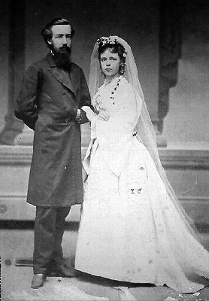
Clara Biltz was the oldest child in the Biltz family. She was born around 1851 when Rev. Biltz was serving the church in Dissen (Friedheim), Missouri. Clara would also have spent part of her childhood in Cumberland, Maryland and Concordia, Missouri. On October 13, 1872, Clara married Martin Luther Wyneken, a twin son of Friedrich Wyneken, who was President of Concordia Theological Seminary, Ft. Wayne, Indiana, and second President of the Lutheran Church-Missouri Synod. Martin was then a pastor in Fort Smith, Arkansas. Clara’s father performed the ceremony in Concordia, Missouri. One wonders how these two young people met and carried on what must have been a long-distance relationship. Would their fathers have taken them on trips they made when Synodical leaders gathered to conduct business? Would Rev. Biltz have traveled to Arkansas to advise a young pastor about starting new congregations and suggested that he meet his unmarried daughter, knowing this young man needed a companion to help him carry out his ministry?
Clara and Martin Luther Wyneken
The Wynekens lived in Ft. Smith, Arkansas where Martin served as the first pastor of First Lutheran Church from 1868-1876. He also served congregations in Van Buren and Little Rock while in Arkansas. In 1876, Rev. Wyneken took a call to become pastor of Trinity Lutheran Church in Cincinnati, Ohio. In 1879, Martin became ill and the Wynekens travelled to California in hopes of regaining his good health. I would imagine that the Wynekens, who by then also had three children, would have stopped in Concordia, Missouri along their way to California to visit the Biltz family. If they did travel through Concordia, I am sure that Rev. Biltz and Maria would have relished some time with their grandchildren. (The photo I have included with the information about Gustav Biltz may have been taken at this time.) Rev. Wyneken would also have then had some time to discuss his new ministry on the West coast with the District President. In 1880, the Wynekens lived in San Francisco with Martin’s sister and brother-in-law, Rev. Jacob Buehler. While in California, Rev. Wyneken visited scattered Lutherans in Los Angeles and Orange County. Rev. Wyneken died in 1884 at the early age of 40. By that time, Clara had moved to the Los Angeles area. For a time, she lived there with her son, Arthur, a Lutheran pastor in Long Beach, California. Clara died on January 19, 1936, and she and her husband are buried in Evergreen Cemetery in Los Angeles.

  - Bertha Biltz
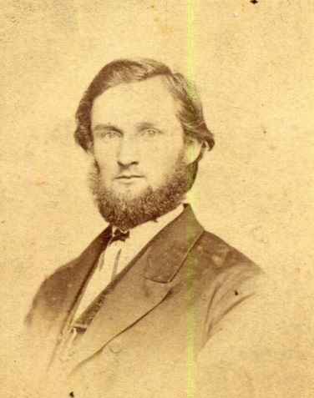
Bertha Biltz was born in Dissen (Friedheim) in 1853. She also spent her childhood in Cumberland, Maryland and Concordia, Missouri. On May 27, 1873, she married Ferdinand Walther, son of C.F.W. Walther. Here again, we can speculate that Bertha and Ferdinand might have met while their parents were conducting Synod’s business. We might also wonder if some of these marriages between members of prominent clergy families may have been arranged by their parents. Ferdinand spent his entire pastoral career in Brunswick, Missouri, only fifty miles from Concordia, Missouri. In 1930, Bertha and Ferdinand lived in St. Louis, Missouri where one of her sons, Rudolph, was a druggist, and a daughter was a saleslady in a drug store. Rudolph operated the Walther Rexall Drug Store about six blocks away from where they lived. After Ferdinand’s death in 1933, Bertha was a clerk at Concordia Publishing House in St. Louis. Bertha died on November 10, 1944. She and her husband are buried in Concordia Cemetery in St. Louis.
Rev. Ferdinand Walther
  - Theodore Biltz
The first son in the Biltz family, Theodore, was born in Cumberland, Maryland, in 1854. Theodore was attending Concordia College in Fort Wayne, Indiana in 1870. The 1880 census indicates that Theodore was living in Morris, Illinois with his younger brother, Julius, where Theodore was a minister. On October 17, 1880, he married Christiane Fritze, a daughter of a Lutheran minister, in Decatur, Indiana. Since Decatur is not far from Ft. Wayne, it is possible these two may have met when Theodore was a student at Concordia College. Theodore died a year later in 1881. He reportedly died as a result of falling off a horse. This occurred during the winter, which makes one wonder whether the weather contributed to this accident, possibly when he was travelling for some reason to visit one of his parishioners. The couple did have a child, Theodora, in 1881. Census data indicates Theodora was born in Missouri. She was baptized at St. Paul’s Lutheran Church in Concordia. Theodore died when Christiane was pregnant with Theodora. After his death in Illinois, Rev. Theodore’s body was transported back to be buried at St. Paul’s Lutheran Cemetery in Concordia, Missouri, and the pregnant Christiane may have moved there to live with the Biltz family where she gave birth to her daughter. I also suspect that Theodora was named after her father. Christiane remarried Rev. John Hamm, whose father had once taught school in Concordia, Missouri, and they started another family. They were married in Strong City, Kansas in 1889, and then were living in Newton, Kansas in 1895. Later, they were living in Okarche, Oklahoma, where she is buried in the Lutheran Cemetery. Theodora lived with a Fritze family in Strong City, Kansas in 1900 and is listed as a granddaughter. She spent most of her life in Strong City and lived to be 100 years old.

  - Adolph Biltz
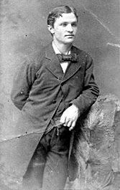
Adolph Biltz was born in 1856 in Cumberland, Maryland. Adolph was never married and lived in a variety of locations during his life. He became a druggist and lived and worked in St. Louis in the late 1800’s and early 1900’s. He worked at several different pharmacies there. During that time, he also served as a hospital steward in the 1st Missouri Infantry during the Spanish American War, which took place in 1898. In 1910, he was a druggist in Portage, Missouri. While there, he also became postmaster in Boekerton, Missouri. Adolph had moved to Jefferson City, Missouri by 1925 and worked at a pharmacy not far from the Missouri State Capitol Building. In 1930, he was living with a Norris family in Eureka Springs, Arkansas and was no longer listed as a druggist. We know he returned to Concordia, Missouri on several occasions because he is included in a few family photographs which were taken there. Adolph died on July 17, 1932 and is buried with his sister, Marie, in Concordia Cemetery in St. Louis.
Adolph Biltz
  - Julius Biltz
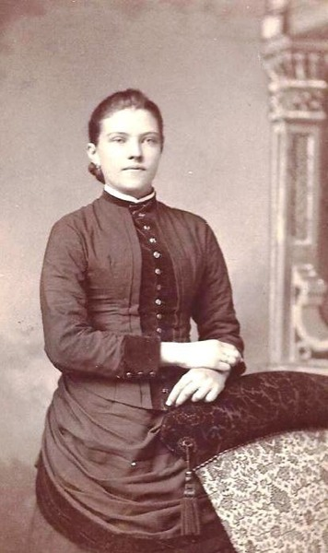
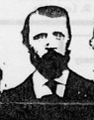
Julius Biltz was born in 1860 in Concordia, Missouri. He was the first child to be baptized in St. Paul’s newly constructed church. After spending his childhood there, he lived later on with his older brother, Theodore, in Morris, Illinois and worked in a furniture factory. He married Paulina Frerking on September 16, 1894 in Concordia, Missouri, with his father performing the ceremony. It is quite possible that Paulina was a childhood friend. In 1900, they were living in Ludell, Kansas where Julius was listed as a general merchant. He would later become a banker there. Julius is said to have helped found St. John’s Lutheran College in Winfield, Kansas. Even though he did not end up in full-time ministry, he, like his father, was very interested in preparing future leaders for the church. Julius was also involved in founding several other Lutheran churches in the Northwest Kansas, Nebraska, and Colorado area. In addition, he was an accomplished pianist/organist. He died on August 6, 1919. Pauline then moved to Rochester with three children, all in their twenties. This move was made in order that one of those children could attend a school for the deaf that was located there. They lived not far from where the Mayo Clinic is now located. Pauline died there on June 22, 1933. Julius and Pauline are both buried with several other members of the Biltz family in St. Paul’s Cemetery in Concordia, Missouri.
Paulina Frerking
Julius Biltz

  - Marie Biltz
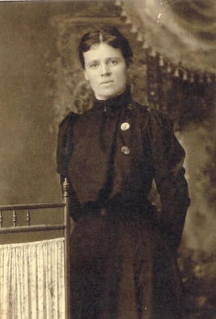
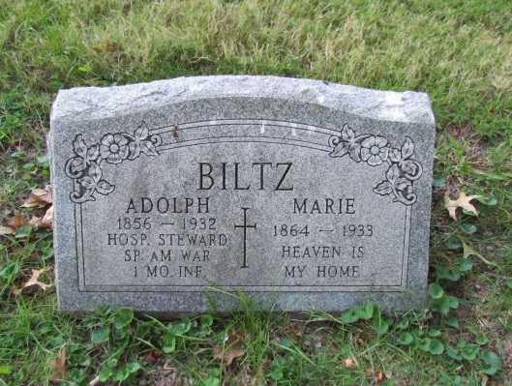
Marie Biltz, often called Mollie, was born in Concordia, Missouri in 1864. She was born at not long after her parents’ confrontation with the bushwhackers during the Civil War. The family had to hide in the woods until it was safe, and as a result, Marie’s baptism had to await a time when the family was secure. Like her brother, Adolph, she never married. She is given much credit for taking care of her father in his old age. After her father died, she continued to live with Molly Giesecke. When her father adopted Molly, I conclude that it was necessary for him to be the adoptive parent, although it would become Marie’s task to raise Molly. Marie became the mother that Molly did not have. Marie was a seamstress at a millinery shop. In 1920, these two were living with Doris Brackmann and her daughter. In 1930, Marie lodged with Molly, who had married Rev. Theodore Brackmann and was living in Puyallup, Washington. When she died in 1933, Marie was living at 2351 Louisiana in St. Louis, the same address as her sister, Bertha. As said before, she is buried with her brother, Adolph, in Concordia Cemetery in St. Louis. I dare say it is not often that you see a brother and sister, neither getting married and living full lives, being buried next to each other, sharing the same gravestone.
Marie Biltz
  - Gustav Biltz
Gustav Biltz was a son who was born in 1865, but his life lasted a mere 25 years. He never married and was buried in St. Paul’s Cemetery in 1890. This was the second boy in the Biltz family who died when he was in his twenties. Several other children were born to the Biltz couple after Gustav, but unfortunately they lived for only a short time.
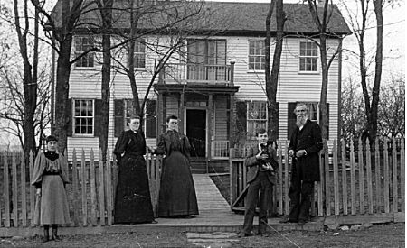
Maria Clara Bertha Gustav Rev. Biltz

  - Bertha Winkler
Bertha Winkler was one of the adopted daughters in the Biltz family. She was the daughter of Theodore and Mary Winkler, who lived in St. Louis in 1880. She was apparently born in Illinois, and her sister, Caroline, was born in Texas. In 1900, she was living with the Biltz family in Concordia, Missouri as a 25 year old adopted daughter. In that census, Bertha is described as being an invalid. In 1910, Bertha was a servant in the house of a Brown family in Denver, Colorado. She was a maid in the Denver area over the years. The last record of her in the city directories of Denver was in 1951.
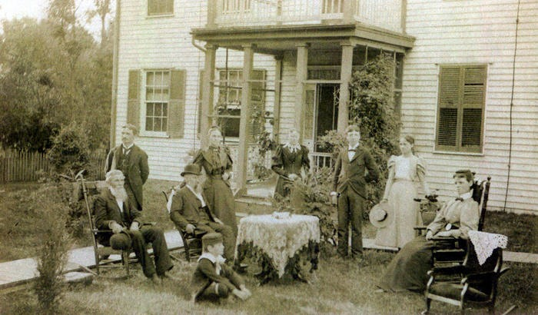
Adolph Biltz Bertha Walther Bertha Winkler Arthur Wyneken Paula Walther
F J Biltz F.G. Walther Mollie Biltz
Julius Walther

  - Marie Giesecke
Marie Giesecke was the other adopted daughter. She was born on March 27, 1895. Her mother had died in 1898, and her father, a local butcher who had other children, probably felt he could not properly care for her. It was then that she began living with the Biltz family. In the census of 1900, Marie was five years old and listed as an adopted daughter. She, like Marie Biltz, was often called by the name Molly. Marie Giesecke married Rev. Theodore Brackmann on August 26, 1923 in Concordia, Missouri. Theodore was also raised in Concordia, Missouri, living with his widowed mother and his grandparents. Another interesting fact was that the two Maries were living with two others that had the surname of Brackmann. Rev. Brackmann served a congregation in Puyallup, Washington. Marie died on March 8, 1984 in Tacoma, Washington. She and her husband are buried in Woodbine Cemetery in Puyallup, Washington. Who could even dream up the life of Marie Giesecke? Born to a family of butchers whose parents were living with her grandparents, only to have her mother die when she was three years old, being adopted by a 72 year old minister, who had been an orphan himself, raised by the preacher’s daughter who never married, perhaps because possible suitors were repelled by her raising an adopted daughter or taking care of an elderly father, living with another family which was likely to become part of her future family, marrying a young Lutheran minister who then takes a call to lead a congregation in Puyallup, Washington, and living her remaining life there, long enough to have her own Social Security card and seeing men walking on the moon. God works in mysterious and marvelous ways!

Robert W. Frizzell, Independent Immigrants: A Settlement of Hanoverian Germans in Western Missouri, (University of Missouri Press, 2007) 102-103

